

|  |
| --- |
| Customer: Ethias |
| Project: |
| Subject: Alfred Finder User's guide |

Release date: 23/05/17

Document history

|  |  |  |  |
| --- | --- | --- | --- |
| Version | Date | Editor | Comments |
| 1.0 | 5/23/17 |  |  |

TABLE OF CONTENT

1 Summary 1

2 Finder page anatomy 2

3 Search box 3

3.1 Date format 4

4 Facets view 4

5 Documents list 5

6 Document details. 7

6.1 Preview 7

6.2 Metadata 8

6.3 Comments 8

7 Alternate page layouts 9

7.1 Embeddable list. 9

7.2 Document preview 10

Alfred Finder User's guide

# Summary

Alfred Finder is a web based application which can be used to consult and leverage Alfresco documents repository. This web interface has been built to be easy to use. You can quickly find documents you need and view their details (content, metadata, comments). Alfred finder is also very flexible, it can be used as a stand-alone application as well as embedded in another existing web application.

# Finder page anatomy

The structure of the finder page is illustrated in the following picture.

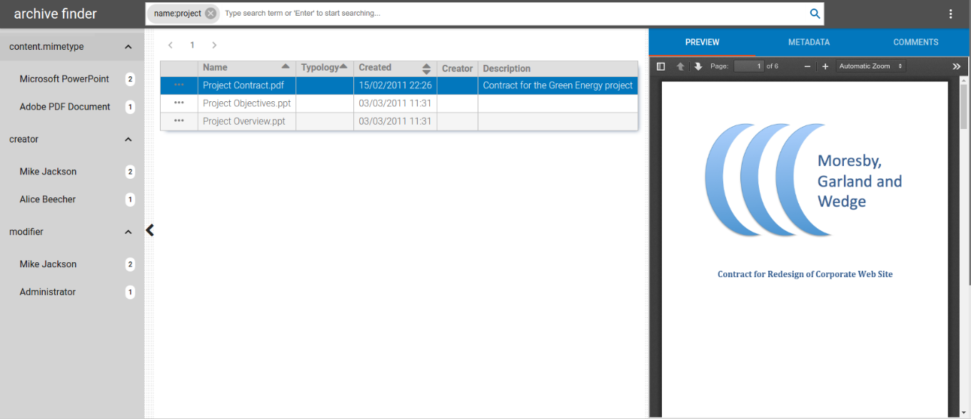

The page is divided into 4 sections:

* At the top, you will find the application header containing the search box as well as the page menu at the right.
* At the left, the facets (or filters) view, which will allow to refine the search criteria with additional filters.
* The central section contains a paged list of documents, result of the search.
* The right side contains the selected document details accessible through a tabbed view allowing you to see alternatively:
  + A preview of the document (in PDF format).
  + All the metadata of the document (editable fields).
  + List of comments linked to the selected document (editable).

# Search box

The search box allows you to add search terms to find for specific documents.

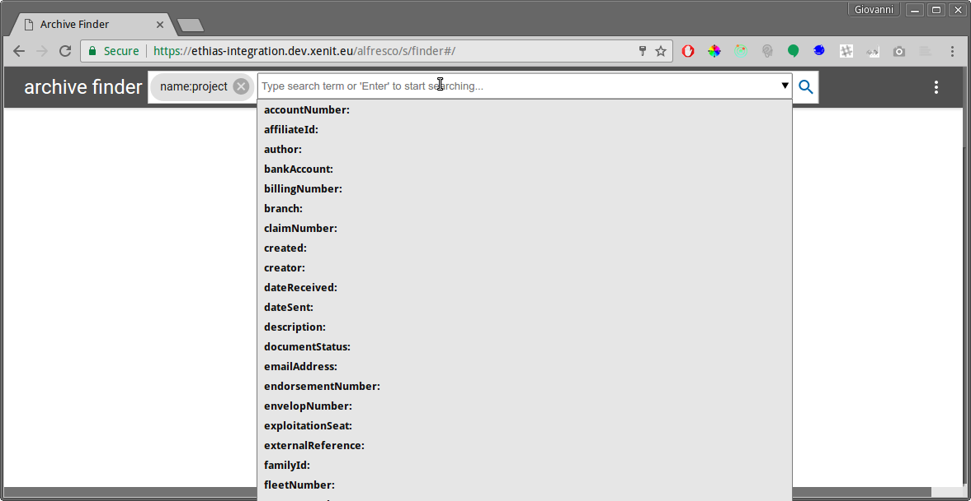

The format of a search term is : <name of property>:<value of property>

To add a search term, you can either:

* start typing the name of the property (if you already know it) and then the sorted list of matching properties is displayed below, you can then select one of them by using the mouse or the up/down keys.
* Click inside the input area and the full sorted list of properties is displayed, you can then either choose one of them or continue the typing.

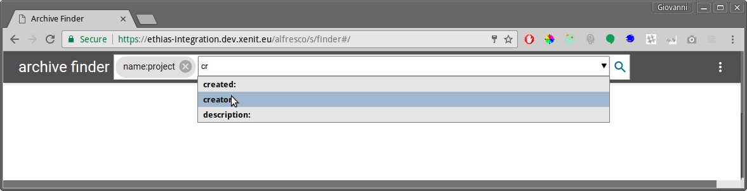

After the selection of the property name, make sure that the ':' (colon) is also present and you can then type the desired value and 'Enter' key to confirm. A new search term chip is then created.

Many search terms can be added and the resulting search list is a list of document matching ALL the search terms ('AND' operation used).

To remove a search term, you can just click on the delete icon of the corresponding search term to remove.

To start the search of matching documents, either click on the magnifier icon at the right of the search box or just press 'Enter' in an empty input area.

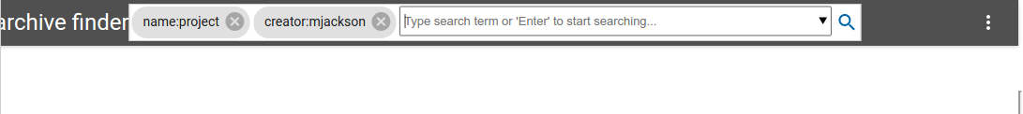

When searching for properties value, you search for an entire word by default. So when searching for the term "start", the following property values will match:

* "start"
* "start of year"
* "since the start"

But not:

* "starter"
* "starting from now"

To match them all, you have to use the wildcard character "*", that way: "start*".

Also, note that using wildcards may have a big impact on the performance of the application.

If no documents can be found, a message will pop up at the bottom of the page indicating that fact.

## Date format

To search with date properties (created, modified, …), use the following format:

YYYY-MM-DD

Example: 2017-07-24

For date range, use the following format:

YYYY-MM-DD..YYYY-MM-DD

Example: 2017-07-24..2017-10-04

# Facets view

After issuing a search, a collapsible view will pop up at the left side of the page. This view will show facts (or filters) that can be used to refine the search query and find more quickly the searched documents. The facets view is a properties list and by clicking on a specific property, a sub list of values with corresponding documents count is displayed.

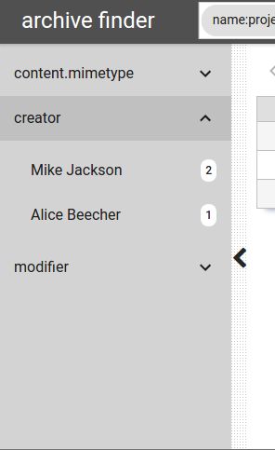

In the example illustrated in the above picture, the list of documents resulting from the last search contains 2 documents with author "Mike Jackson" and 1 documents with author "Alice Beecher".

If you click on a specific value, an additional term is added to the search box corresponding to the selected value and new search is issued.

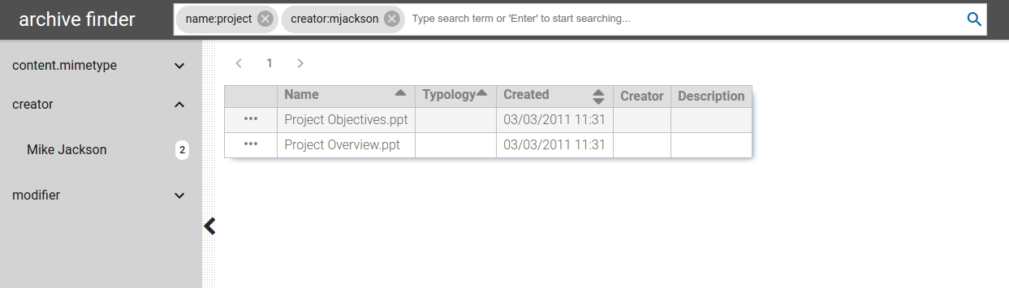

If you want to hide the facets view and have more space for the other elements in the page, you can click on the caret icon at the right of the facets view.

# Documents list

The list of documents, result of the search is a paged list (by default, 15 documents per page). You can view a specific page by selecting the page number at the top of the list. For performance reasons, only the first 15 pages are shown and accessible.The list of documents can be sorted by clicking on the up/down arrow icons at the right side of some properties in the table header. When clicking on the icon the first time, the table is sorted in ascending order based on the corresponding property. After a second click, the order is descending. And finally, a third click deactivate the ordering. When no order is applied for the column both the up and down icons are shown.

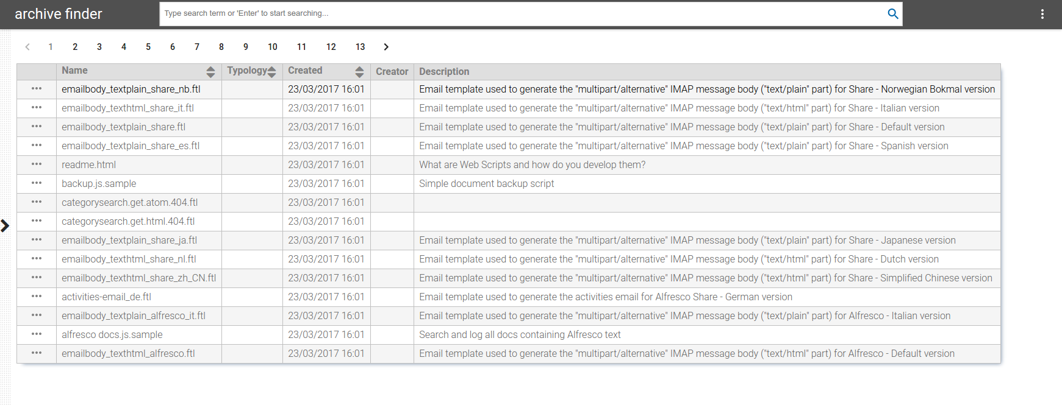

By clicking on a row corresponding to a document (all columns except first column, row menu), the details of that document are displayed at the right side of the page.

By clicking in the first column of the document list, you trigger the display of the row menu I.E. menu specific to the document.

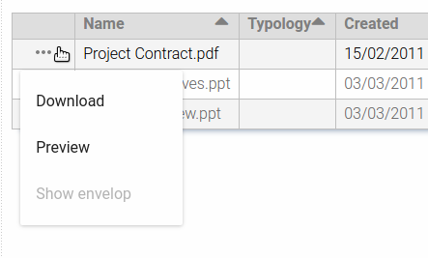

Three actions are then possible:

* Download of the document in its original format.
* Open a preview of the document in a separate page of the browser.
* Open a separate browser windows with the list of documents which belong to the same envelop as the current document. This menu is only active if the current document has an envelopNr property filled in.

# Document details.

The selection of a document in the list gives you access to the document details at the right side of the page.

## Preview

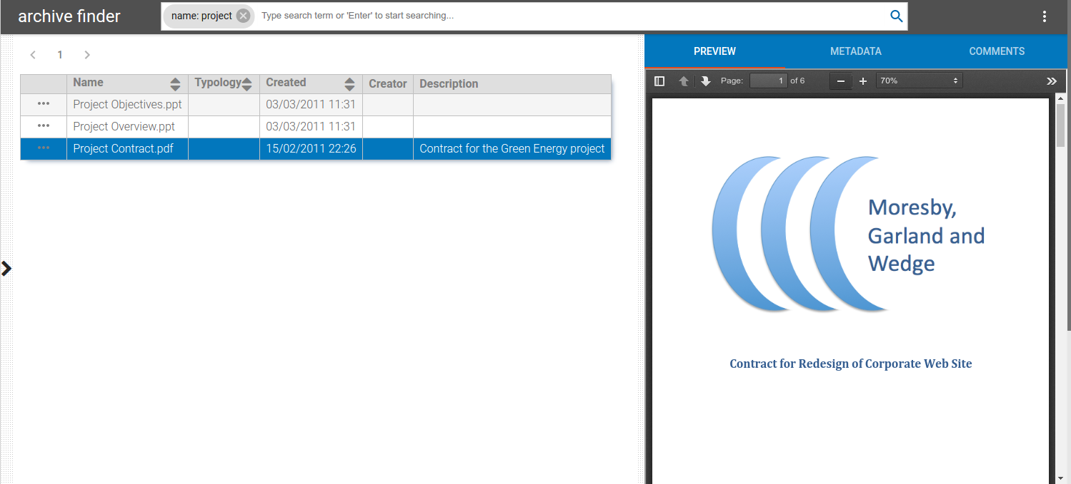

The first tab of this view (default one) allows you to visualize the document content through a PDF viewer. This viewer offers a couple of options to navigate the document:

* The first button (at the left) opens a thumbnail view of all the pages of the document.
* The up/down arrows allows you a quick access to the next/previous page.
* The next input box gives you the possibility to quick jump to a specific page.
* The -/+ buttons could be used to zoom out/in the document content.
* The right side button gives you more useful options.

## Metadata

The second tab allows you to view and modify (if you have the permission to) the metadata of the current document.

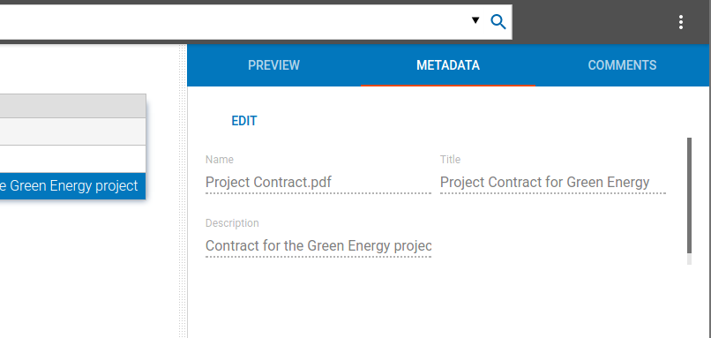

To be able to edit the metadata, you have first to click on the "EDIT" button at the top. Don't forget to push "SAVE" to save all your changes.

## Comments

The third tab displays the comments linked the current document.

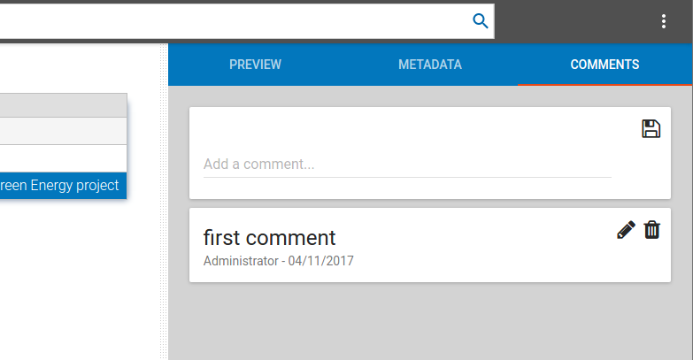

In the comments' view, the top most box allows you to add a new comment. The following blocks are the existing comments which can be edited or removed (with appropriate permissions).

# Alternate page layouts

## Embeddable list.

When calling the finder web app with a specific URL (query URL), the search box is not shown anymore but only the facets, documents list and document details view are visible.

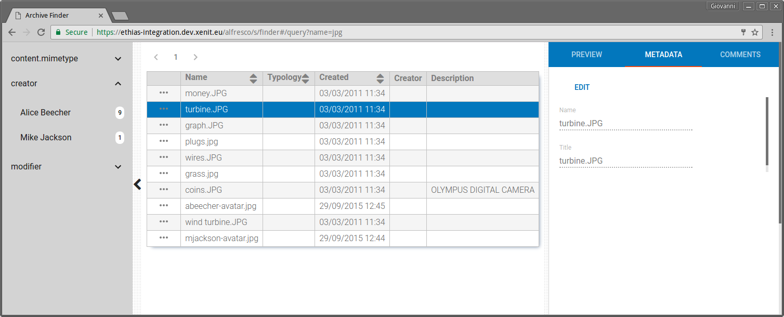

### URL Format:

http://<host>:<port>/alfresco/s/finder#/query?<query-parameters>

with:

* name of server where the finder app has been installed
* port to be used (if different to 80)
* query-parameters : see below.

### Query parameters.

* search criteria in the form: <field-name1>=<value1>&<field-name2>=<value2> with possible field names:
  + name
  + policyNumber
  + claimNumber
  + billingNumber
  + partyRole
  + legacyId
  + pathDocumentum
  + subjectOfCatastroph
  + envelopNumber
  + all : allows to query on all fields here above.
  + all=** : gets all data.
* pageSize: number of items to be displayed on a page (optional, default = 15).
* page: number of the page to be displayed (optional, default = 1).

If more than one criteria are requested, they will be combined with an "AND" operator.

Note: URL query parameters should be URL encoded.

### Examples

* [http://localhost:8080/alfresco/s/finder#/query?policyNumber=1234](http://localhost:8080/alfresco/s/finder" \l "/query?policyNumber=1234)
* [http://localhost:8080/alfresco/s/finder#/query?all=**&pageSize=10&page=3](http://localhost:8080/alfresco/s/finder" \l "/query?all=**&pageSize=10&page=3)
* [http://localhost:8080/alfresco/s/finder#/query?name=png&pageSize=5&page=2](http://localhost:8080/alfresco/s/finder" \l "/query?name=png&pageSize=5&page=2)
* [http://localhost:8080/alfresco/s/finder#/query?claimNumber=444](http://localhost:8080/alfresco/s/finder" \l "/query?claimNumber=444)

## Document preview

The finder web app may also display a specific document in a separate page.

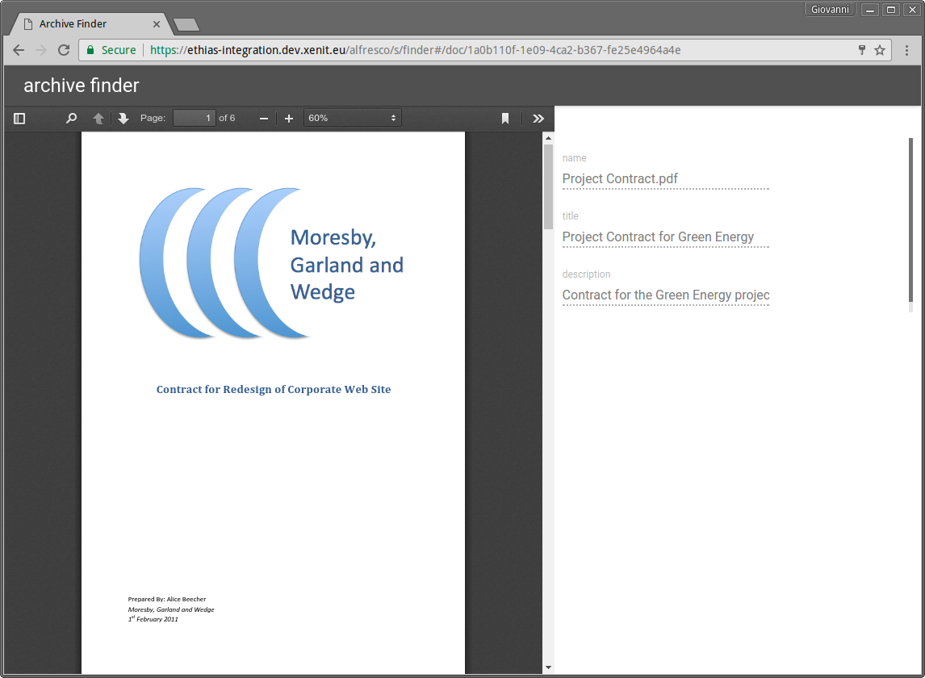

This view, which displays the content of the document with associated metadata at the right side, can be requested using this specific URL:

http://<host>:<port>/alfresco/s/finder#/doc/<uuid>

Where <uuid> has to be replaced by the alfresco internal identifier of the document to be shown.

Note: on this view, the metadata are not editable.